# Vincent Noce

02/19/2024

CS-255

# CS 255 System Design Document Template

This template lays out all the different sections that you need to complete for Project Two. Each section has guidance to prompt your thinking. You will need to continually reference the interview transcript as you work to make sure that you are addressing your client’s needs. There is no required length for the final document. Instead the goal is to complete each section based on what your client’s needs are. Remove this note when you are finished, and replace all bracketed text with the relevant information.

## UML Diagrams

### UML Use Case Diagram

*[In Module Six, you were asked to complete a use case diagram based on your system design. If you would like to make any adjustments to your diagram, please do so. Please insert your use case diagram here. Check to make sure that you included appropriate components and symbols and that your design 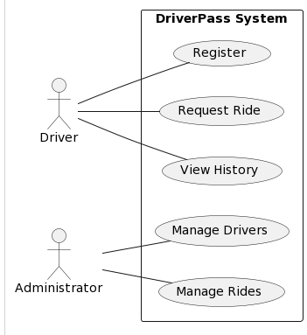*

### UML Activity Diagrams

*[You were asked to choose* ***two*** *use cases and create* ***two*** *activity diagrams, one for each use case. Please insert* ***both*** *of your activity diagrams here. Check to make sure that you included appropriate components and symbols and that your design meets the client’s needs.]  
  
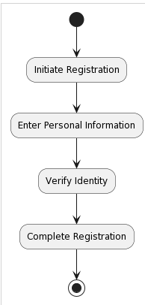*  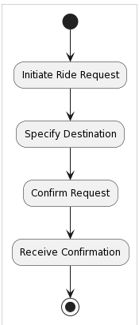

### UML Sequence Diagram

*[You were asked to create a sequence diagram based on* ***one*** *of the use cases you chose. Please insert your sequence diagram here. Check to make sure that you included appropriate components and symbols and that your design meets the client’s needs.]*

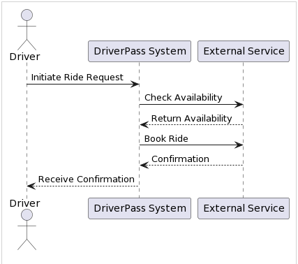

### UML Class Diagram

*[You were asked to create a class diagram based on the different classes and attributes needed for your system design. You are* ***not*** *required to include methods, but you may if you wish. Please insert your class diagram here. Check to make sure that you included appropriate components and symbols and that your design meets the client’s requirements.]*

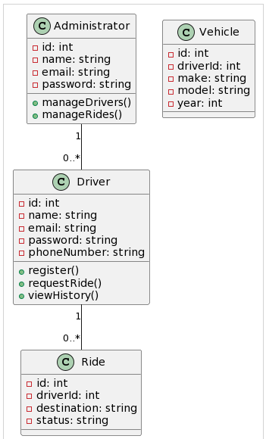

## Technical Requirements

*[Based on the diagrams you have created, describe the technical requirements of your system. These requirements should address the required hardware, software, tools, and infrastructure necessary for your system design.]*

Hardware Requirements

* Servers will be required to host the application and database. For concurrent user requests to be handled efficiently, the servers must be equipped with adequate processing power, memory, and storage.
* To accommodate increasing demand without compromising performance, the hardware infrastructure should be scalable to accommodate the expected traffic and scalability requirements.

Software Requirements

* Frontend Development User-friendly and responsive interfaces will be created using HTML, CSS, and JavaScript for DriverPass' frontend.
* Backend Development Business logic, user authentication, and database interactions will be handled by Node.js or Python in the backend.
* Database Management System Data on users, rides, and other relevant information will be stored in a relational database management system (RDBMS) like MySQL or PostgreSQL.
* Version Control System Source code will be managed, changes will be tracked, and collaboration among team members will be facilitated by a version control system such as Git.
* Integrated Development Environment (IDE) Code, debugging, and project management will be performed using IDEs such as Visual Studio Code or JetBrains IntelliJ IDEA.

Tools Requirements

* UML Modeling Tool The UML diagrams will be created and visualized using UMLet PlantUML, which is a UML modeling tool.
* Project Management Platform- To track tasks, assign responsibilities, and monitor progress on a project, a project management platform will be used, such as Jira or Trello.
* Continuous Integration/Continuous Deployment (CI/CD) Tool A streamlined development process will be ensured with the implementation of CI/CD tools like Jenkins or Travis CI.
* Testing Framework Unit testing, integration testing, and ensuring the reliability and quality of the system will be performed through testing frameworks such as Jest for JavaScript or PyTest for Python.

Infrastructure Requirements

* Hosting Platform There are a number of reliable hosting platforms that can be used to deploy the DriverPass system, including Amazon Web Services (AWS), Google Cloud Platform (GCP), and Microsoft Azure. In order to ensure uninterrupted service, the hosting platform should be scalable, highly available, and secure.
* Monitoring and Logging System performance, metrics, and potential issues will be monitored by monitoring tools like Prometheus and Datadog. In order to troubleshoot and debug system problems, we are going to implement logging frameworks such as Log4j and Winston.
* Security Measures- In order to safeguard user data, encryption at rest and in transit, HTTPS encryption, and user authentication mechanisms (such as OAuth) will be implemented.